**Theory Questions:**

**Mod-1**

**DFA vs NFa**

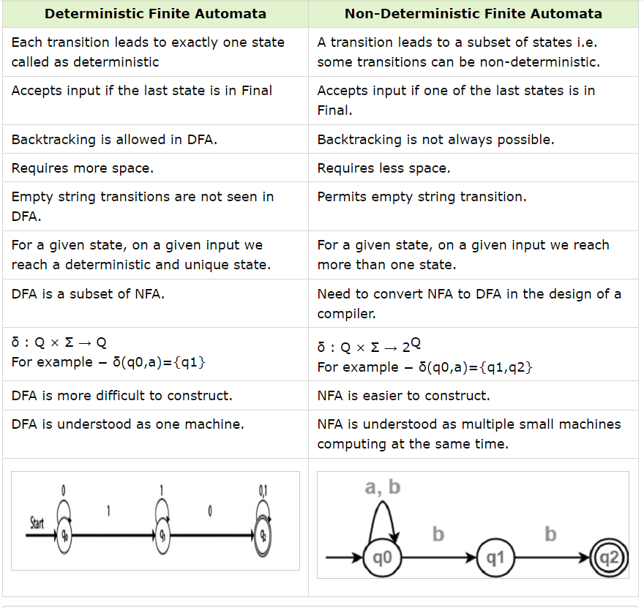

**Concept of Automata**

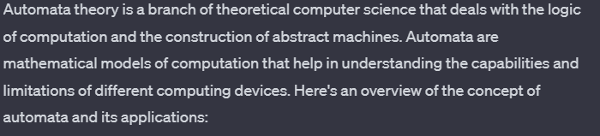

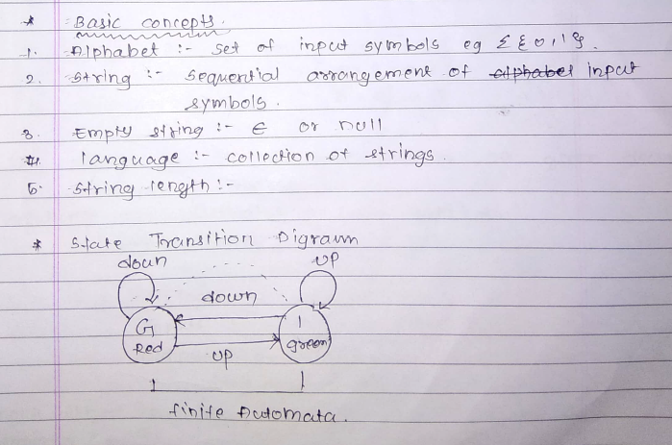

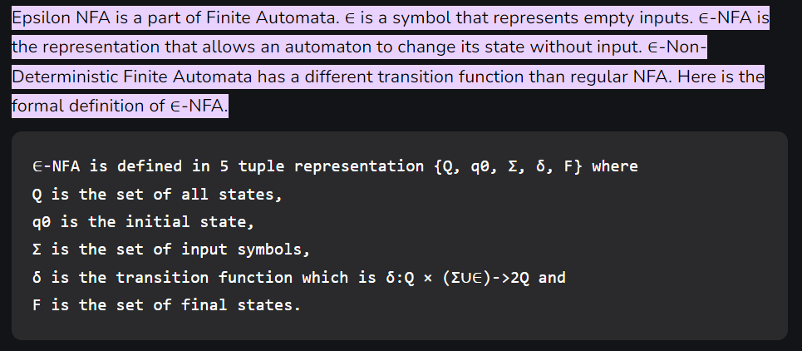

**Mod-2**

**Regular Language Properties:**

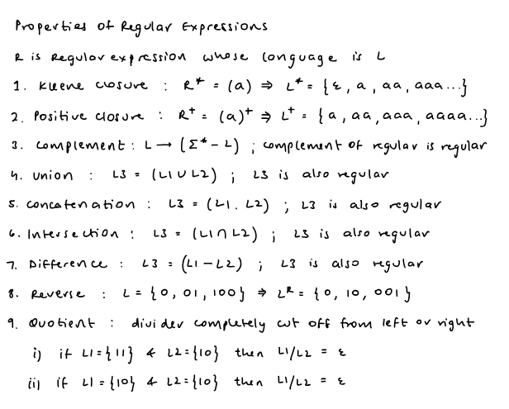

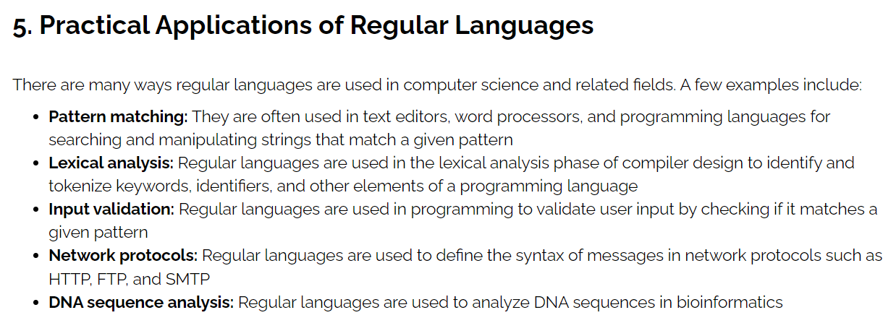

**Arden’s Theorem:**

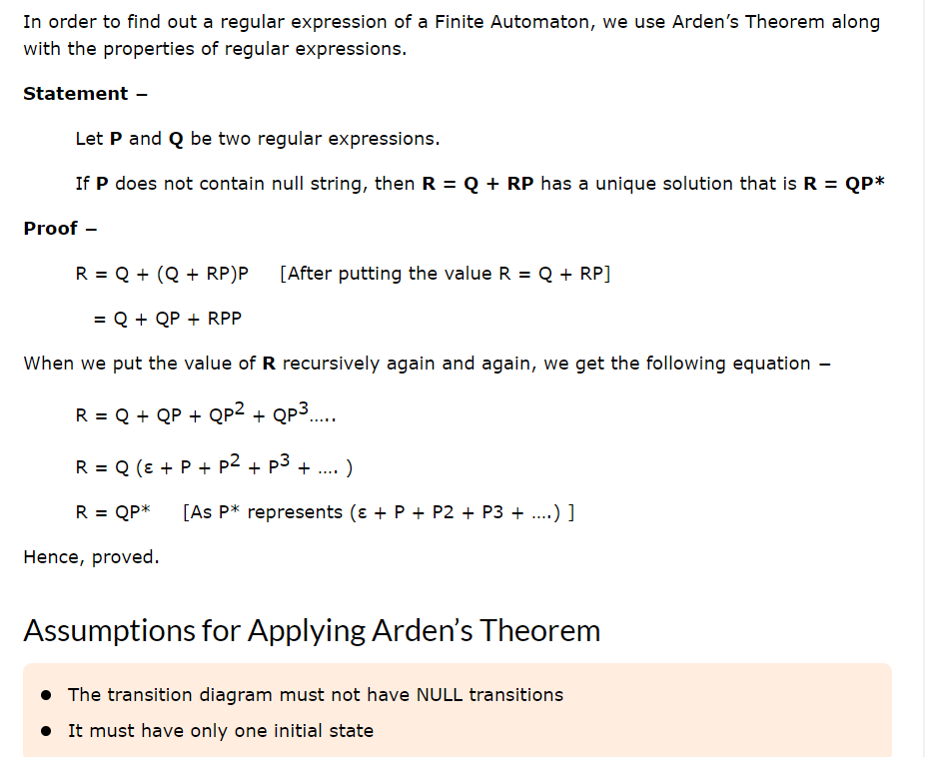

**Pumping lemma for regular langauges:**

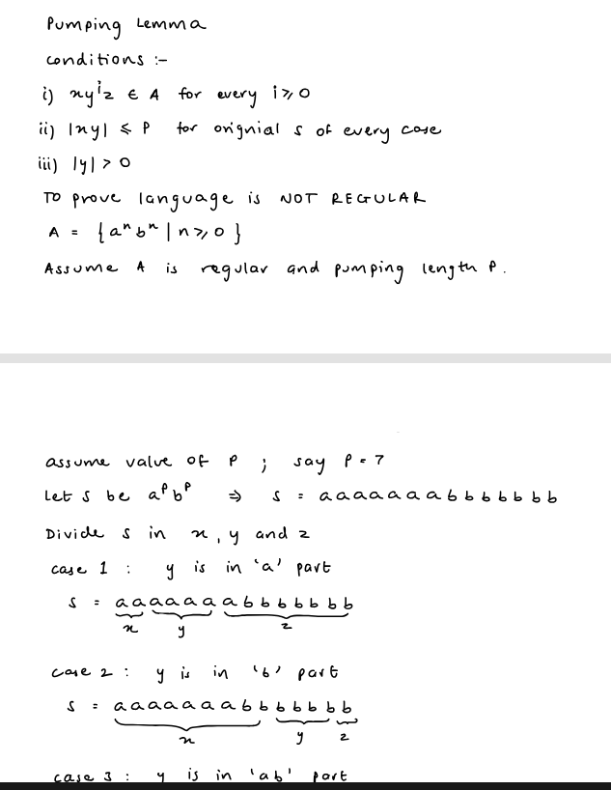

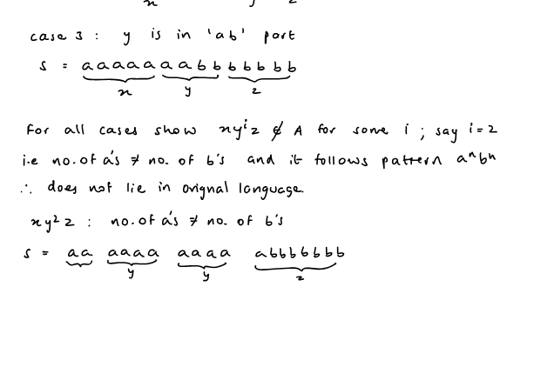

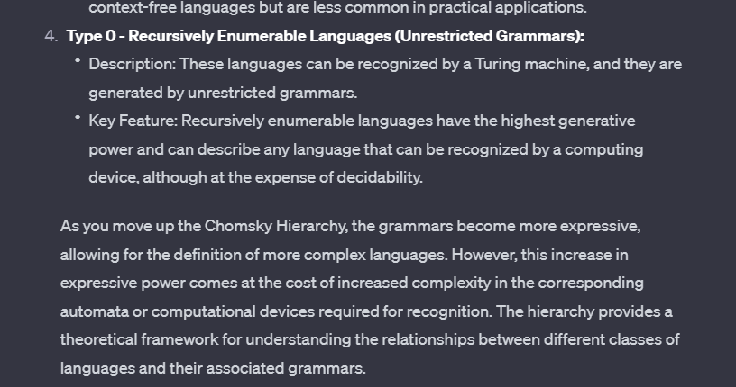**Chomsky Heirarchy:**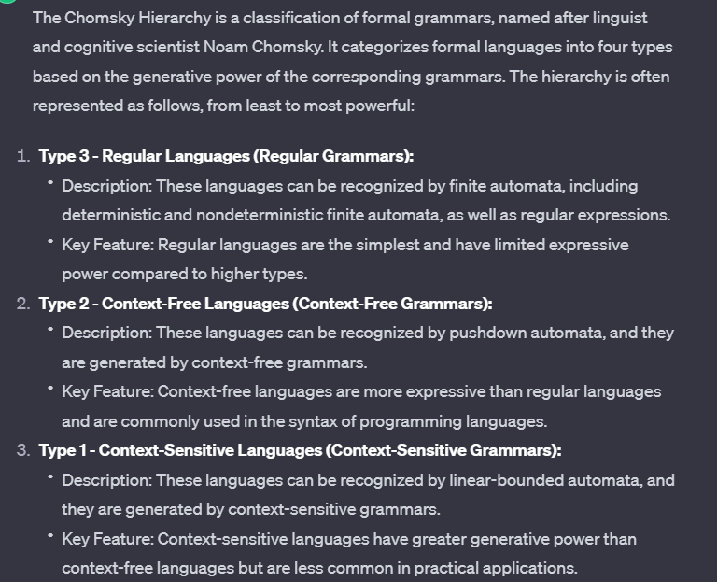

**Mod-4**

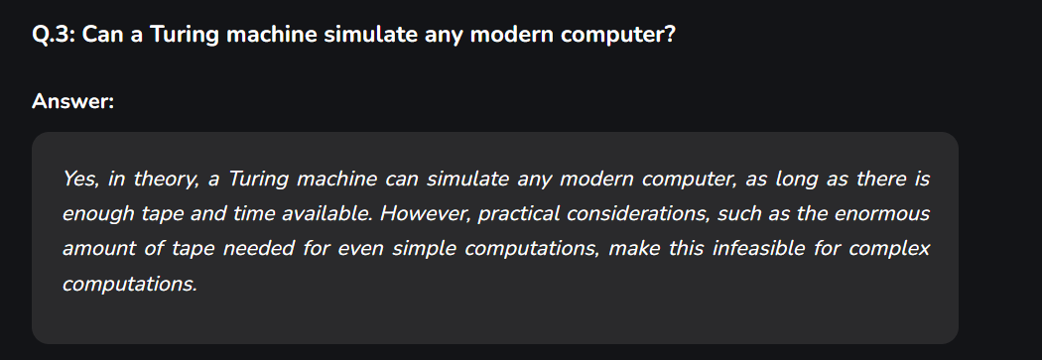

**Universal Turing machine:**

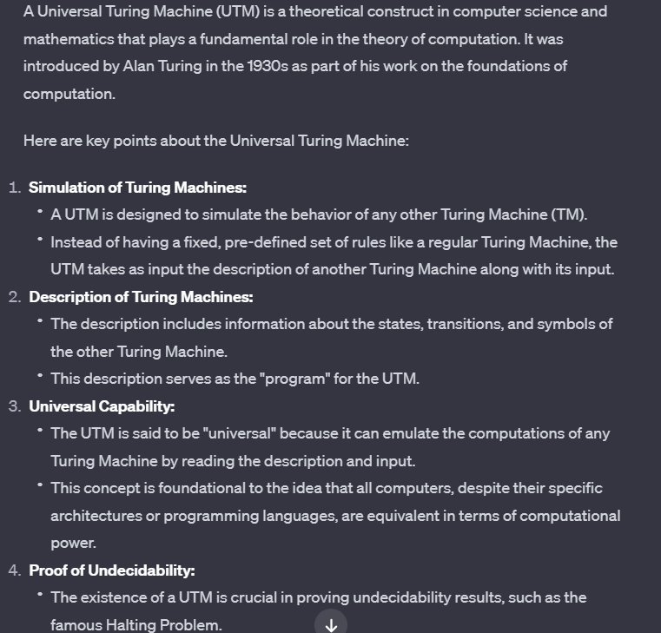

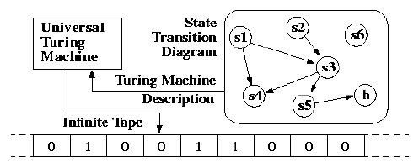

**Turing Machine:**

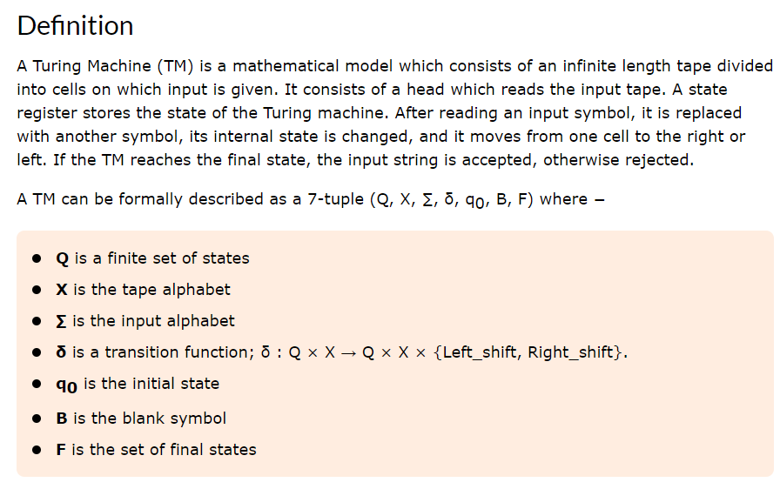

**Variations of turing machine:**

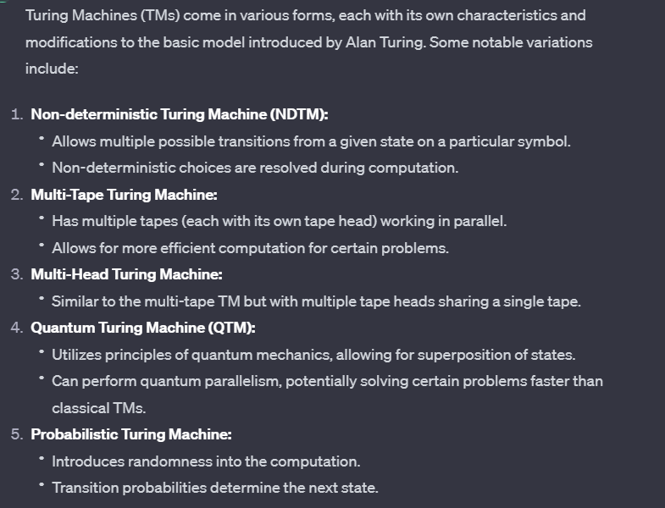

**Church Turing-thesis:**

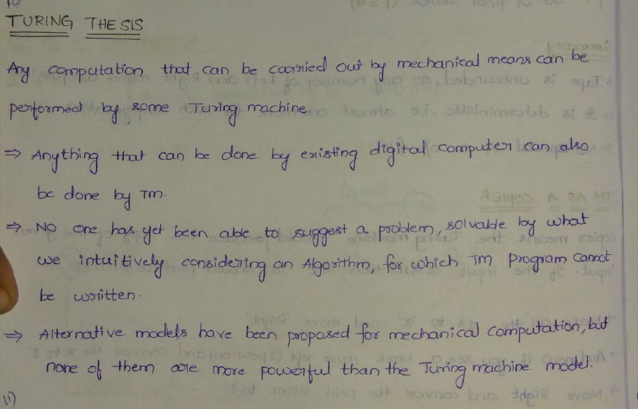

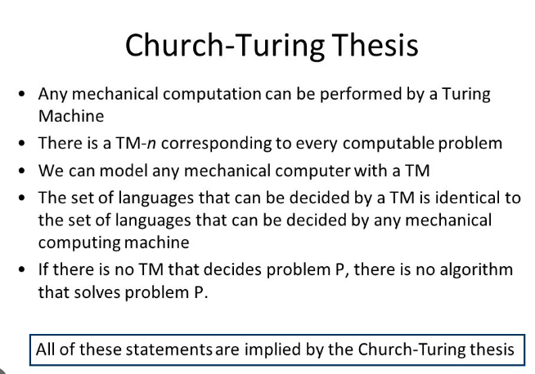

**Halting Problem:**

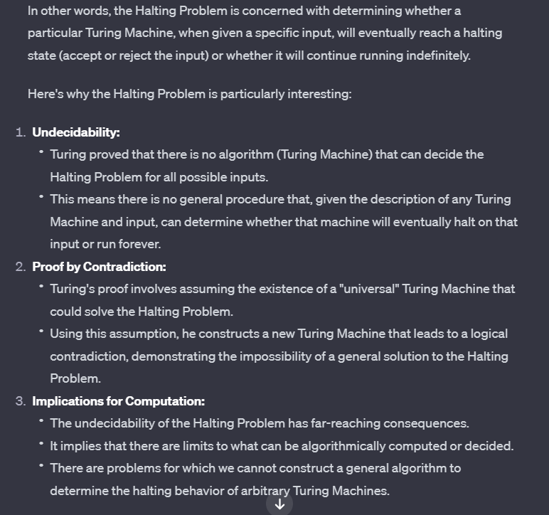

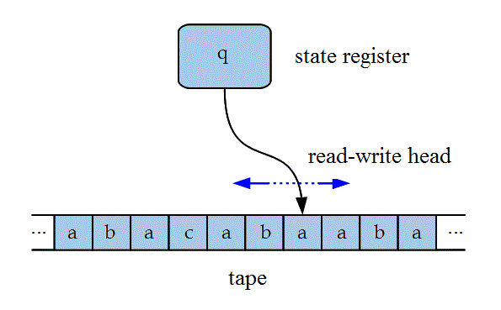

When describing Turing machines (TMs) and their components, several key terms and concepts are commonly used in the field of theoretical computer science. Here's a list of important terminology related to Turing machines:

1. **Tape:**
   * The infinite tape on which symbols can be written. It extends indefinitely in both directions.
2. **Alphabet:**
   * The set of symbols that can appear on the tape.
3. **Head:**
   * The read/write head that scans a single tape cell at a time and can move left or right.
4. **State:**
   * The internal state of the Turing machine. The machine's behavior is determined by its current state.
5. **Transition Function (δ):**
   * A function that defines how the Turing machine transitions from one state to another based on the current symbol being read.
6. **Configuration:**
   * A snapshot of the Turing machine's current state, the symbols on the tape, and the position of the tape head.
7. **Accepting State:**
   * A state in which the Turing machine enters when it successfully recognizes the input, indicating acceptance of the input.
8. **Rejecting State:**
   * A state in which the Turing machine enters when it determines that the input is not accepted.

**Hilberts problems**

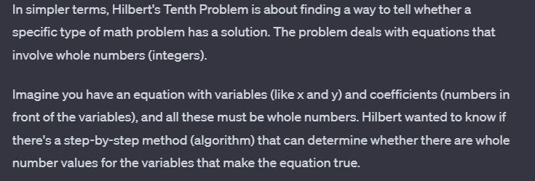

**Mod-5**

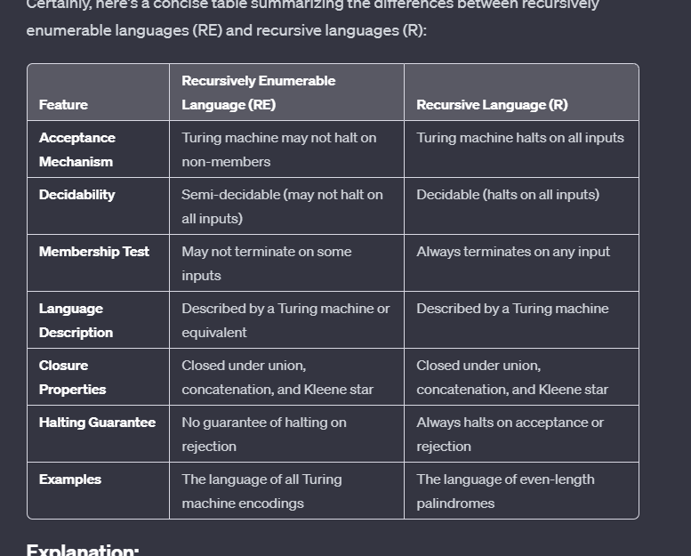

**Post Correspondance Problem:**

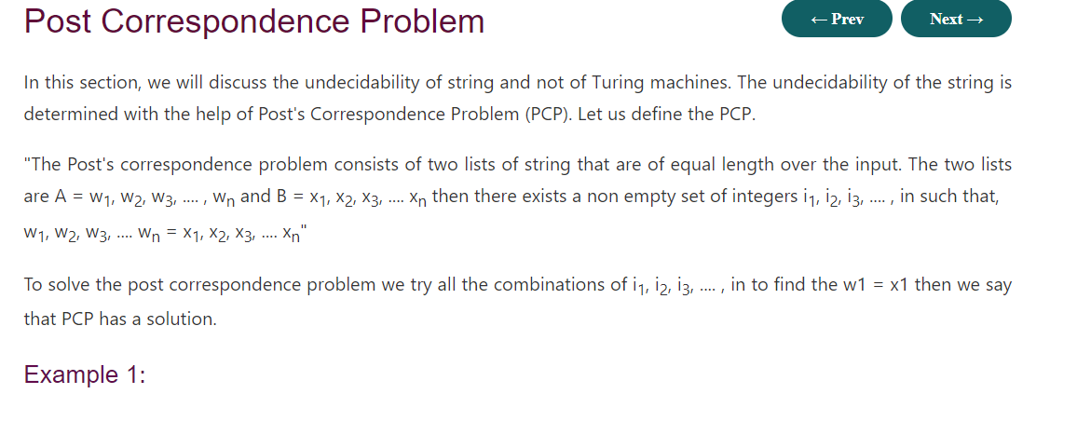

**Undecidable problems about Turing Machine**

